MODULE 1 — LOGIN & CONNECTION COMMANDS

1. Write the SnowSQL command to log in using account + username.

We use username and password to authenticate ourselves and securely access Snowflake from command prompt.

snowsql -a <account_name> -u <username>

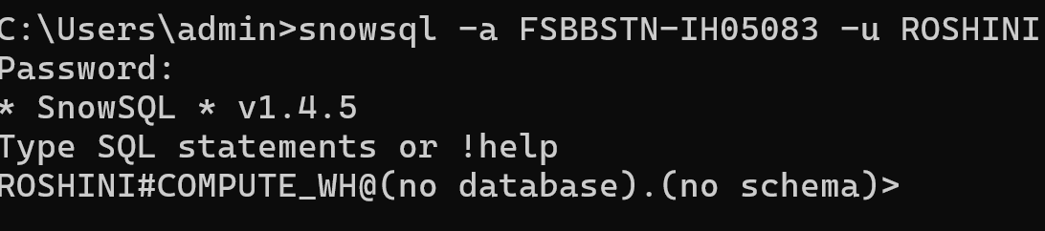

snowsql -a FSBBSTN-IH05083 -u ROSHINI

2. Write the command to log in and automatically select a role.

In SnowSQL command prompt, ROLE is used to control what actions you can perform inside Snowflake.
Full control over everything.
Manage users, roles, billing, security.

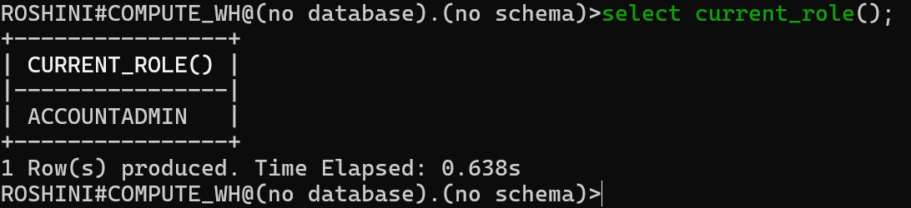

select current_role(); ACCOUNTADMIN

3. Write the command to log in and use a default warehouse.

A warehouse provides computing power to run SQL queries.Because without a warehouse, you cannot run SELECT, INSERT, COPY INTO etc.

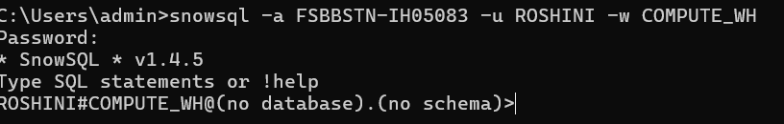

snowsql -a FSBBSTN-IH05083 -u ROSHINI -w COMPUTE_WH

4. Write the command to log in and set a default database & schema.

A database is like a big cupboard.Inside the cupboard, you store multiple folders.
A schema is like a folder inside the cupboard.Inside the folder, you keep tables, views, files etc.

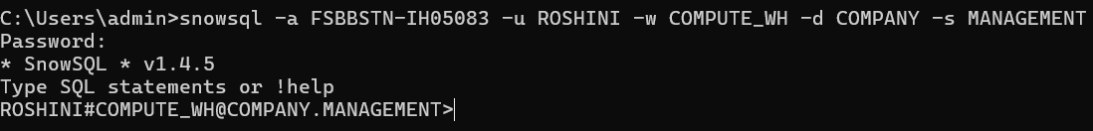

snowsql -a FSBBSTN-IH05083 -u ROSHINI -w COMPUTE_WH
-d COMPANY -s MANAGEMENT

5. Write the command to log in using a private key instead of a password.

We use a private key for secure, password-less authentication when connecting to Snowflake using tools like SnowSQL, Informatica, Python, ETL jobs, etc.

snowsql -a <account_name> -u <username> --private-key-path snowflake_key.p8

Step-1 openssl genrsa -out rsa_key.pem 2048

Step-2 openssl pkcs8 -topk8 -inform PEM -outform PEM -in rsa_key.pem -out rsa_key.p8 -nocrypt

Step-3 openssl rsa -in rsa_key.pem -pubout -out rsa_key.pub

step- 4 type rsa_key.pub

Step-5 ALTER USER <username> SET RSA_PUBLIC_KEY='PASTE_PUBLIC_KEY_HERE';

6. Write the command to check the version of SnowSQL.

When we run commands in SnowSQL or any software, we give the version to check which version of the tool is installed.

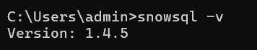

Snowsql -v SnowSQL 1.4,5

7. Write a SnowSQL command that logs in and runs a single SQL query.

snowsql -a <account_name> -u <username> -r <role> -d <database>
-s<schema> -q "<SQL_query>"

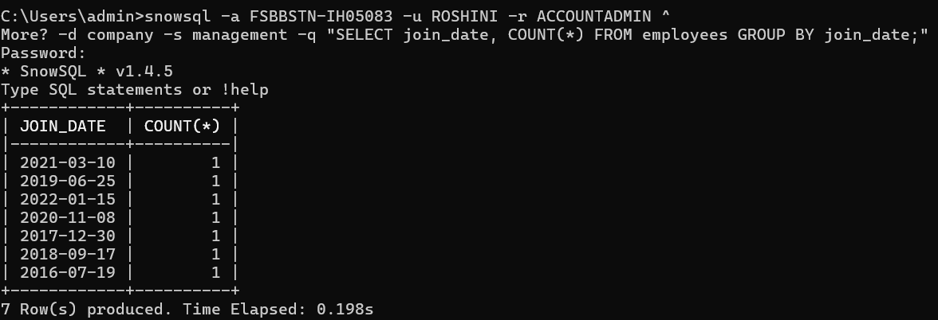

Snowsql -a FSBBSTN-IH05083 -u ROSHINI -r ACCOUNTADMIN ^
-d company -s management
-q "SELECT join_date, COUNT(*) FROM employees GROUP BY join_date;"

8. Write a command that logs in and saves the session output to a file.

snowsql -a <account_name> -u <username> -r <role> -o output_file="<file_name>"

Snowsql -a FSBBSTN-IH05083 -u ROSHINI -r ACCOUNTADMIN
-o output_file="C:\Users\admin\Downloads\session_output.txt"

Explain : When i log in to Snowflake using SnowSQL, how can i save everything that appears on the screen into a file.Like output file-local folder (i took employee in my folder).

MODULE 2 — CONNECTION PROFILES

9. Write the configuration for a connection profile named "dev_conn".

dev_conn = easy shortcut for our Snowflake login settings.
Focus is on profile name (dev_conn).

[connections.dev_conn]
Account = FSBBSTN-IH05083
user = ROSHINI
password = cera@123@123CERA

snowsql -c dev_conn;

10. Write the SnowSQL command to use a profile named "test_conn".

snowsql -c test_conn;

11. Create a connection profile with warehouse, database, and schema included.

Focus is on including warehouse, database, schema (profile name does
NOT matter).

[connections.dev_conn]

warehouse = COMPUTE_WH
Database = company
Schema = management

12. Create a profile with default role specified.

[connections.dev_conn]

role = ACCOUNTADMIN

MODULE 3 — RUNNING SQL QUERIES

13. Run an inline SQL query using SnowSQL.

Run the SQL query directly in one single command.
.
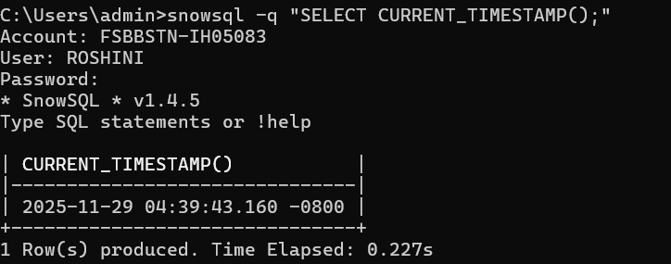
snowsql -q "SELECT CURRENT_TIMESTAMP();"

14. Run multiple SQL statements using a single SnowSQL command.

Executed one SnowSQL command where multiple SQL statements were placed inside the -q option, separated by semicolons, allowing SnowSQL to run them sequentially (create table → insert data → select data).

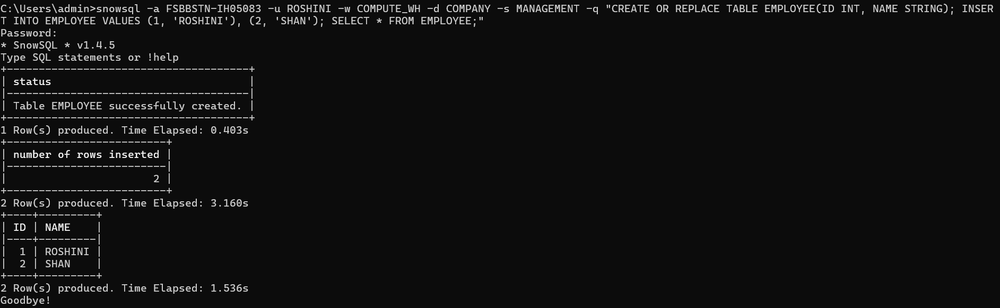

Single SQL = one instruction
Eg : (Select * from employee)
Multiple SQL = many instructions at once
Eg : (Use database test_db;
Use schema public;
Select * from employee);

15. Execute a SQL file named create_tables.sql using SnowSQL.

Snowsql -a FSBBSTN-IH05083 -u ROSHINI
-f 'C:/Users/admin/Downloads/create_tables.sql.txt'

This file url is path of that create_tables.sql.

16. Run a SQL file using a connection profile.

snowsql -c dev_conn -f create_tables.sql

17. Run a query and suppress all output formatting.

snowsql -c dev_conn -q "SELECT * FROM employees;" -o output_format=tsv

Snowsql → opens SnowSQL
-c dev_conn → uses your saved login profile.
-q select*from employees → runs this query.
-o output_format = tsv → prints plain, simple text, no tables or borders.

